

|  |  |  |  |  |  |  |  |  |
| --- | --- | --- | --- | --- | --- | --- | --- | --- |
|  | | | | | | | | |
|  | | Kernighan Lin Algorithm | | | | |  | |
|  |  | | | | | | |  |
|  | | | |  |  | | | |
|  | | | | Keerthan Nayak |  | | | |
|  | | | | 11/29/2020—ECE 528 VLSI CAD 1 |  | | | |
|  | | |  | | |  | | |

**Kernighan Lin Algorithm:**

**Initial Step 1:**

The first line of the input contains 2 integers. The first represents the node and second represents the edges.

The initial is to read the input file and print out a partition.

If a file contains 2n vertices, then (1………. n) vertices will be in 1st partition and (n+1,…..2n) will be in the second partition.

If there are odd vertices, then a dummy vertex needs to be added.

**Steps to run on Windows :**

**Step 1:** Open command prompt.

**Step 2:** In the command prompt type **python KLfinal.py.**

**Step 3:** Enter the input file name**.**

**Steps to run in linux environment:**

I have uploaded the final source code in git.

You can use the following commands:

**git clone** [**https://github.com/Keerthan1994/KL-Algorithm.git**](https://github.com/Keerthan1994/KL-Algorithm.git)

**cd /KL-Algorithm/KL Algorithm**

**python3 KLfinal.py**

You would require version python 3 or above

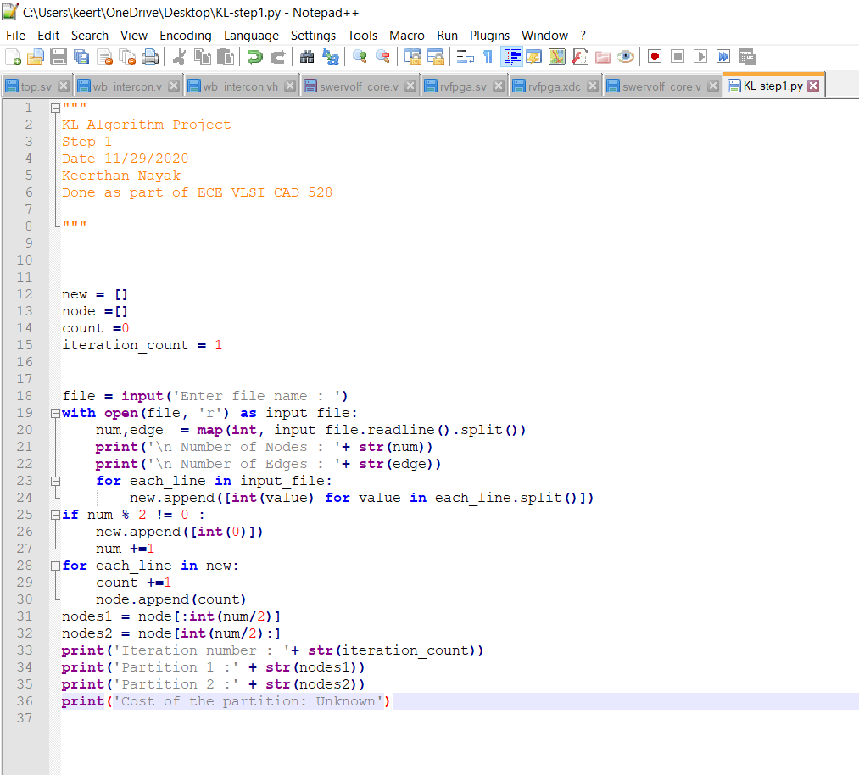

**Output:**

The file for tested for odd and even nodes.

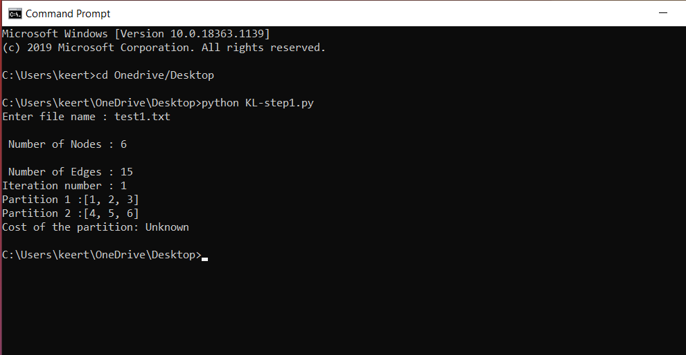

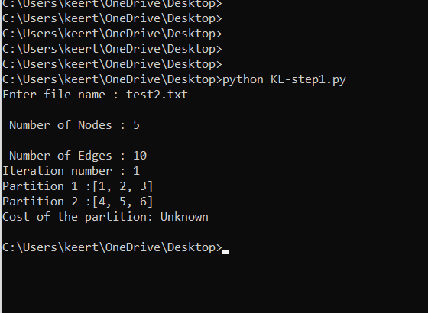

**STEP 2: KL Algorithm**

The program was further modified to add the below functionality.

A. Calculate a cost of a partition

B. Cost of a partition is a number of edges with one end in Partition 1 and one in Partition 2

C. Update your Output format to show “cost of the partition”

Test1.txt

File with even vertices.

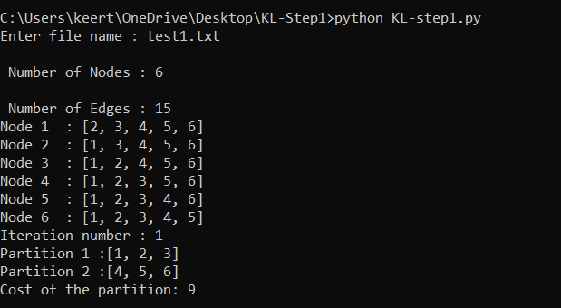

Since each vertex in partition A is connected to every vertex in Partition B the cost of the partition is 9.

**FINAL STEP**

Calculations Performed for KL Algorithm is shown below:

